

**Marketing Report**

**Document Control**

|  |  |  |  |
| --- | --- | --- | --- |
| **Editor** | **Version** | **Date** | **Update** |
| **Jake Ransom** | **1.0** | **02/06/2015** | **Document Creation** |
|  |  |  |  |
|  |  |  |  |

**Table of Contents**

1.0 First Heading 4

1.1 Sub Heading: 4

**Type of Document**

# 1.0 Introduction

Marketing is an integral part of a company’s ability to produce products for which a substantial demand and need exists, without these aspects a company would be blind to whether a product would saleable or useful.

The marketing strategy has been based on several aspects:

* Survey results (small explanation for each )
* Advertising Techniques
* Competitor Analysis
* Market Distribution

# Background Research

**2.1 Market Research**

*“the action or activity of gathering information about consumer’s needs & preferences.”*

*Market research techniques:*

* Surveys; Using concise and straight forward questionnaires, you can analyse a sample group that represents your target market. The larger the sample the more reliable the results will be.
  + Online surveys, are the simplest way to gather a large amount of data. They are quick and inexpensive. However they can be unpredictable as you have little control over the respondents.
  + In-person surveys, these are done in high traffic locations such as shopping centres or high streets. The allow people to be presented with the product with a direct explanation of what it is. This again can be unpredictable as you have little control of who you will survey and if they represent your target market. These can be expensive and time consuming.
* Focus groups; a moderator uses a scripted series of questions or topics to lead a discussion among a group of people. Preferably at a location with video taping equipment or one-way mirrors. It would take around 3 groups to get a relatively balanced result, again the larger the pool of people the more reliable the data.
* Personal interviews; these are very similar to focus groups except that it is with only a single person at a time.
* Observation; this is where you would observe a potential customer performing the action you are trying to solve. This would give you an actual insight the persons behaviour rather than a thought out answer in a survey.
* Field Trials; these are used to test out the product on a selected group of people. This provides real world usage of the product and will show any modifications that need adjusting.

**2.2 Marketing**

*“the action of promoting & selling products or services, including market research and advertising.”*

## 2.2.1 Promotion techniques

*Ways to promote brand awareness (company name)*

* + Social media
  + Leverage on web searches, use “search-engine optimization” so that the site can appear higher on related searches.
  + Use traditional methods, such as print in newspapers or magiazines. These could be general or specific to the genre associated to the company.
  + Sponsor public events, such as a charity event. This would appear in a favourable light to the customer, that the company’s sole goal isn’t to make a quick profit.
  + Network with leading brands in a similar field
  + Companies tell a story of their history; this engages customers on a personable level. Capturing an interest in learning about the company’s heritage and “where it all started”. This type allows for a more interesting way of explaining the companies goals and service. This only works if a company has a history though.
  + Behind the scenes; this gives a snapshot into some of the inner working s of the company. Which could be used to show the process of how a consultation meeting might go … etc
  + Customer service
  + Being “Edgy”, creating content such as viral videos
  + Testimonials from previous customers

*Ways to promote the product:*

* + Special trial deals or using a free period to try out the product. This will make a potential customer more likely to try the product and ultimately purchase a full version. This method is used by most companies creating programmes.
  + Promote giveaways on social media
  + Crowdfunding Platforms, such as Tilt. This will not only promote the product but generate financial support.
  + Online Ads (similar to pop ups).
  + Use “Influencers” to talk about the product. These are people who frequently discuss the genre you are targeting and have a large fan-base. This gives a credible source that potential customers will use as a guide to purchase quality products.
  + Printed promotional material, such as simple flyers/leaflets or pamphlets that detail the product spec.
  + Business cards, detailing the specific product the company is known for. Works well for companies with a sole product.
  + Create sample sizes of products to offer to credible people in industry. To give feedback and a positive reviews.

## 2.2.2 Selling Techniques

“understanding the way a product is seen by the customer is critical to selling it. [3]”

* Know the customer:
  + Understand the roles, responsibilities and objectives of your audience.
  + What is in it for the customer ?
* Don’t be pushy with sales:
  + Being too pushy with sales will put a potential customer off
  + Don’t “spam” customers
  + Ask customers what they want, whether this is before the product is launched or after
* Understand your product:
  + Know the product inside and out, from its initial idea to a fully realised product
  + If you fully know the product the customer will to
* Be personable:
  + Logic and information won’t sell a product alone, the customer needs to feel you’re on their side and understand their issues.
  + Be in the mind-set of a customer’s needs instead of the companies
* Show the advantage of the product:
  + What makes the product better than others in the industry ?
  + Show the superior effectiveness, convenience, value for money, etc…
* Fit the customer’s current routine:
  + What effort is there in switching from the current method to your product ?
  + The product won’t be tried or used by any potential customer if the cost if greater than its relative advantage.
* Work right out of the box:
  + Make sure the product is intuitive, easy to use and works straight away
  + Make it reliable
* Make the benefits easy to spot:
  + Make sure that the customer can quickly see the benefit of the product, this will enable the product to sell itself.
  + Have an open easy to view product
* Use offers/discounts/trials:
  + Use tempting offers to initially get a customer to test the product

[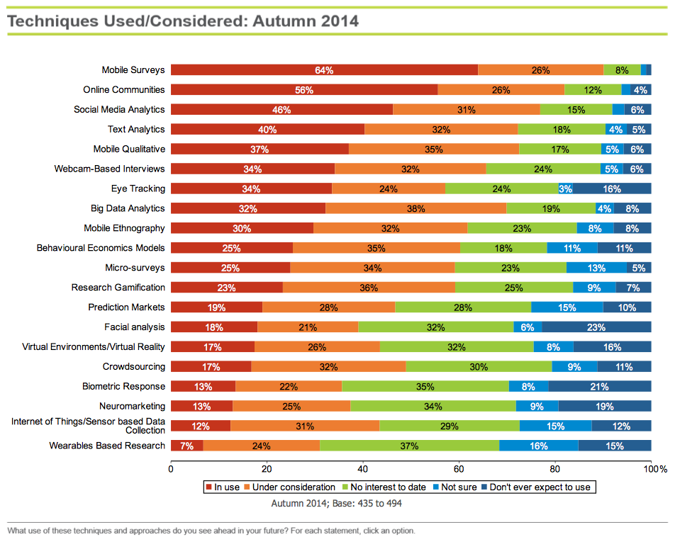](http://www.greenbookblog.org/wp-content/uploads/2014/09/GBpost1.png)

*Fig.1 Advertising Techniques Used/Considered: Autumn 2014 [1]*

[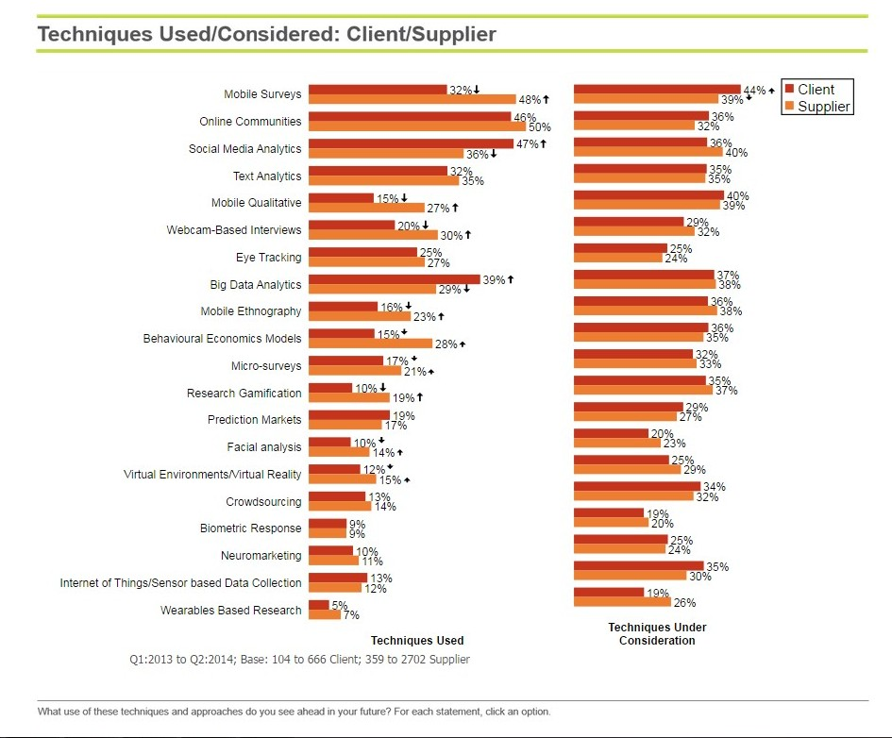](http://www.greenbookblog.org/wp-content/uploads/2014/09/Client-vs.-Supplier-New-Method-Usage-e1411991362736.jpg)

*Fig.2 Advertising Techniques Used/Considered: Client/Supplier [1]*

**­**

# 3.0 Advertisement

*“any public notice, as a printed display in a newspaper, short film on television, announcement on radio, etc, designed to sell goods, publicize an event, etc.* ***”***

**Types of advertising:**

* **Press release** - A press release is a written or recorded communication directed at members of the news media for the purpose of announcing something ostensibly newsworthy.
* **TV Ad** – Make a creative TV ad and run it at a time when your target audience will most likely be watching. You could film your own ad, purchase a pre-made ad and record a voiceover or enlist the help of a commercial production company. However make sure it’s entertaining and looks professional.
* **Radio Ad** - Advertise on your local radio station, or a larger station if your budget allows. Make sure your voice captures attention and presents the type of character you want people to associate with your business.
* **Print Ad** - Magazines let you easily target a particular audience – just pick the trade or consumer publication they read most. You’ll tend to reach a more affluent audience with magazines, too. Newspapers and regional magazines let you reach the audience in your area. Consider a full-page ad for maximum impact, choosing a design that entertains or makes people pause to think.
* **Interpersonal Networking** - Always carry business cards and brochures for your product and be prepared to pitch your product to any receptive audience. Attend social events and talk about what you offer, giving a card and brochure to each person you talk with.
* **Online Networking** - Connect with other professionals who serve a similar customer base but aren’t competing with you. Agree to post their link on your website if they post yours on their site. Connect with friends and acquaintances on social networks after developing a page for your business or a professional profile. Send notices about sales, your new product and responses to it.
* **Online Content** - Develop easy-to-read content for your website, incorporating commonly searched for terms in your writing. Join site submission networks like Digg, where you submit links to your content. Submit quality links to other sites so you’ll get higher ratings, too. Consider writing a blog or e-newsletter, doing a podcast or producing instructive YouTube videos.
* **Direct Mail** - Start a direct-mailing campaign by sending letters or e-mails to clients or potential customers. Consider highlighting the product feature that your target audience will find most important.
* **Events** - Attending local, regional and even national events will help you connect with many potential customers. Conduct demonstrations on how to use the product or perform a related task and talk with as many attendees as possible.

# 4.0 Ethics and Philosophy [2], [4]:

Ensure the ethics and philosophies of your organisation are moral and sound. Modern Customers gravitate towards the ethics and philosophies of a company much more in recent years than before.

Customers have grown increasingly sceptical of business’s being solely about greed and “getting one over on the common customer”. So a business that encourages moral ethics and a philosophy that puts a customer’s needs first would shine above a lot of its competitors.

Being open and truthful about what the product actual delivers will go much further than exaggerating points. Having trust that the advertisement is accurately describing the product will give it credibility and returned sales.

Using transparency and the above points mentioned with the social media (& word of mouth) the company will be marketed much more effectively than a slick exaggerated marketing scheme.

This also applies to the way in which advertisements should be used, respecting the customer and not pushing sales will get a company much further.

# 5.0 Sofia’s Marketing & Advertisement Techniques

**5.1 What market research techniques will be used:**

* Several Surveys will be used to show demand for the company’s product and to gather information on the gap in the market.
* Field trails will be implemented at the end of the product development in the form of a month free trial.

**5.2 What marketing processes we will use:**

The initial marketing processes used will be due to their cost and effectives at targeting a large audience.

* Traditional methods such as print in newspapers and magazines. As this is targeted at a large section of teachers/tutors.
* Creating an Edgy viral video would work, and is easy to implement. However there is no guarantee it would go viral.
* Targeted e-mails at clients such as schools. These should come across friendly & personable. To make a distinction between “spam” and random advertising.
* Social media: this method is free if using it to showcase the company in a group (Facebook) or a video (YouTubeOnline Networking would be again an easy to implement method, by using non-competing companies it won’t detract from our company product. It’s makes it simple to add updates about the product that people will be notified about.
* Online ads, this is a simple method that can be targeted at specific websites that teachers/tutors are most likely to visit. ) These will be targeted ads based on either google, YouTube or Facebook.

# 6.0 Competitor Analysis

The main competitors were analysed to gauge how Sofia should market and price the product against the methods used by these companies.

A main competitor was defined as one who has a large customer base, popular within its respective field and supplies learning aid software.

## Doddle

***“****Doddle* ***is an online resource providing teaching, homework and assessment across 19 subjects”***

**Product Description:**

**Doddle is an interactive pre-made content driven piece of software that offers customers 19 modules with pre-made content ranging from KS3 to As-Level content.**

**The program allows homework to be assigned and assessment tracking of students.**

**Sales tactics used:**

* Video advertising
* Implying the students’ needs first
* Using testimonials teachers and schools who uses doddle
* Buzzwords
* Use case studies to show people who have/used doddle
* Use a live chat system on the website
* Use a lot of follow up assistance after purchase
* Using a subscription service for purchasing doddle.
* Separated out individual subjects
* Provide an interactive demo of the product
* 2 different lengths of subscription

**Brief Summary:**

All of the advertising seems to be done through the website. No links to social media such as facebook or youtube.

They use a lot of testimonials off customers who have purchased the product.

The subscription list is pretty long, cramped and a little confusing at first. The main benefit here is being able to meet individual subject needs or a whole package. They seem to try and push the Doddle Suite as the main selling point, which includes more after care and tailoring options.

The site is quite easy to navigate around and find what you’re looking for.

It’s assumed the selling strategy is word of mouth and direct sales from the lack of other sources found. I.e. no social media links or ads found. The only advertising that was found was done through reviews on forums [aa]

**Limitations:**

**Purely online based**

## MyMaths

*“MyMaths is an interactive online teaching and homework subscription website for schools that builds pupil engagement and consolidates maths knowledge”*

**Product Description:**

MyMaths is an interactive pre-made content driven piece of software that specialises in maths. The content ranges from primary to post 16 level content.

The program allows homework to be assigned and assessment tracking of students.

**Sales tactics used:**

* Able to use on multiple devices. Which are available to download from iTunes & Android
* Updates on new content
* Video to demonstrate the product, however the video is a bit stale.
* Use a review system to show testomonials of people who have used MyMaths
* Also targeting parents, by mentioning and allowing them to view progress
* Use a subscription service for purchasing MyMaths
* Seperates out 3 distinct levels
* Unlimited access for that school and all its students.

**Brief summary:**

All of the advertising seems to be done through the website. No links to social media such as facebook or youtube.

They use a review system to show the comments from people who have used the product.

The subscription list is split into 3 categories clearly listed. The content they provide is also clearly labelled.

The site isn’t very easy to navigate around, and there is no initial description what the product is.

Just like doddle its assumed MyMaths uses word of mouth and forum discussion [ab] as its main selling strategy.

## WizIQ

*“WizIQ is a SaaS-based online education platform, connecting educators and learners for live and self-paced courses.”[ag]*

**Product Description:**

WizIQ is an online live classroom driven piece of software, it allows the user to give live lessons to their students. The program is pushed towards K-12 level users and learning management businesses (LMS) [ag].

The program allows users to create assignments and tests which have a progress tracking ability.

**Sales tactics used [ac]:**

* Video advertising
* Intuitive and Easy site
* Using testimonials teachers and schools who uses WizIQ
* Organizations and University’s clearly shown using the product on home screen
* 30 day Free trial
* Buzzwords
* Use case studies to show people who have/used WizIQ
* Use a live chat system on the website
* Using a subscription service for purchasing WizIQ.
* Tailoring options for price depending on school type and teacher & student count
* Provide an interactive demo of the product
* Links to Facebook, twitter, LinkedIn and YouTube
* Sponsored events [ad]
* Competition Offers [ad]

**Brief Summary:**

Multiple forms of advertising used including company website, social media, magazine [af] and influencers [ae].

They use a lot of testimonials and shown companies who use WizIQ.

Have links to many social media site including Facebook and YouTube.

Many tailoring options for pricing which opens up a wider customer base.

## PowerPoint

*“PowerPoint is a presentation software program that is part of the Microsoft Office package”*

**Product Description:**

PowerPoint is a tool used to create and show user customised content. Typical school uses are when Teachers use it to create lesson and revision material to present to their students.

It allows full customisability of slides containing many options in terms of graphics and text.

**Sales tactics we plan to use based off competitors:**

* Video advertising
* Imply the teachers and students needs first
* Use testimonials & case studies (this is only applicable after several sales)
* Buzzwords, to grab attention
* Use a live chat system
* Have an instructional video
* Have plenty of follow up assistance and after-care
* Use a subscription service/licensing
* Eventually allow the use on multiple devices
* Keep the web site simplistic
* Allow a free trial of the product

**Pricing:**

MyMaths – Online service  
Costing (licensing):

|  |  |
| --- | --- |
| Subscription Type | Price (1 year) |
| Primary | £265 |
| Secondary | £565 |
| Post 16 | £565 |

Doddle – Online service

Costing (liscensing):

|  |  |  |
| --- | --- | --- |
| Subscription Type | Price (1 year) | Price (3 year) |
| Doddel Suite* | £6900 | £15,900 |
| Science suite (KS3, KS4 & A-lvl) | £1649 | £3899 |
| Science (KS3 & KS4) | £999 | £2399 |
| A-lvl Science | £999 | £2399 |
| Maths | £999 | £2399 |
| GCSE statistics | £399 | £899 |
| Maths Bundle (maths & GCSE stats) | £1299 | £2899 |
| English | £999 | £2399 |
| ICT & Computing | £999 | £2399 |
| MFL suite (French, German & Spanish) | £1499 | £3199 |
| French | £899 | £1999 |
| Spanish | £599 | £1399 |
| German | £599 | £1399 |
| Geography | £399 | £899 |
| History | £399 | £899 |
| RS | £399 | £899 |
| Citizenship | £399 | £899 |
| PSHEE | £399 | £899 |
| Business Studies | £399 | £899 |
| D&T | £299 | £699 |
| PE | £399 | £899 |
| Art & Design | £299 | £699 |
| Drama | £299 | £699 |

*\*Included in the Suite:***KS3 and KS4:** science, maths, English, ICT & computing, French, German, Spanish, geography, history, RS, citizenship, PSHEE, D&T, art & design, music and drama. **KS4:** business studies and PE.

**What method of pricing we should use:**

Since we are a new company, the pricing will be lower than those of the established competing companies.

However under cutting the other companies has advantages; it will seem more attractive to customers since we are charging less.

We will keep the licencing simple and provide only a few of types similar to MyMaths and WizIQ.   
The varying factor between each type will be the number of students that can view the lessons and whether they are an individual subscription or a school.

A product key will be given in order to protect against the distribution of the product, outside of the allocated students. A company will most likely be used by Sofia to generate these product keys to save on time developing our own system.

Doddle = £6900/yr per school

MyMath = £265 or £565 /yr per school

WizIQ = £299 ($470)/yr 1 academy

TeachEasy = ??

Advertising Prices

Market Share

Market Distribution

Product Fit/Gap in market (technology in education)

Online vs Application

# Appendix A

Wiz IQ Sales Chat using Online service:

1. Jake, Marketing Manger of Sofia
2. Aditya, Sales representative of WizIQ

**(1)** Im looking into using an online teaching platform to teach my students, it has to be able to allow my students to view my course content. And then take periodic tests which I can then view that feedback. Does this program satisy this ?

And can you tell me about wizIQ in general ?

**(2)** I just reviewed your query and yes we do provide a solution for those requirements. In a nutshell, WizIQ is an online teaching platform where you deliver live virtual classes, courses, testing and analytics. All seamlessly connected & tailored as per your needs

**(1)** okay sounds great, can written content be uploaded and shared with students ?

**(2)** Yes, of course. You get a content library from where you directly share any office documents(word, excel, ppt, pdf, pictures, movies, audio files etc) and a whiteboard to interact with what you bring in  
You may also directly use the free hand tool and a digital pen to write on the whiteboard.

Please click on the link below to get a feature demonstration of the WizIQ Virtual Classroom.

**(1)** Great, all sounds promisng. I will check out the link shortly. How would the students access this content ? And what is the lisencing for the product ?

**(2)** You may share your content by class or course depending on your wishes. They get access to it directly based on the permissions you set.

Our licensing is very simple. We have no limits on the number of classes or courses you deliver. We just need to determine the maximum number of students you would like to teach per class session.

How many students do you usually teach per class ?

|  |  |
| --- | --- |
|  |  |

**(1)** It can be small tutor groups 3-5, or large groups upto 40-50

**(2)** Our starting plan is 1 virtual classroom with 10 attendees for $190/yr. Unlimited number of classes with up to 10 students per class session. The next tier is 25, 50, 100 and so forth.

For your requirement we would configure a 50 attendee package which would be ideal.

The 50 attendee solution costs $470/yr. All premium plans include unlimited class recordings, 15 GB Content Library, Co-Branding, Polling, 10 break out roos, 24x7 tech support and live in class support as well.

**(1)** With these plans, can I only share the classes with the same set of students ? OR can it be 50 varying students per class ?

**(2)** Yes it applies to any 50 students per class

Refs:

[1] <http://www.greenbookblog.org/2014/09/29/the-top-20-emerging-methods-in-market-research-a-grit-sneak-peek/>

[2] <http://www.businessballs.com/market.htm>

[3] <http://predictableprofits.com/winning-consumer-trust-skeptical-market/>

[4] <http://www.inc.com/steve-tobak/how-to-sell-anything-to-anybody.html>

[5] <http://fitsmallbusiness.com/how-much-does-facebook-advertising-cost/>

[6] <http://www.pennapowers.com/how-much-do-ads-on-youtube-cost/>

[7] <http://smallbusiness.chron.com/promote-new-product-marketing-activities-1722.html>

[8] <http://www.theguardian.com/education/2013/jun/21/primary-school-class-sizes-rise>

[aa] <http://www.edugeek.net/forums/educational-software/113655-any-doddlelearn-users.html>

[ab] <https://community.tes.co.uk/tes_mathematics/f/25/t/698751.aspx>

[ac] <https://www.wiziq.com/>

[ad] <https://www.wiziq.com/press-releases/>

[ae] http://techcircle.vccircle.com/2014/05/20/wiziq-launches-online-learning-marketplace-to-offer-live-instructor-led-learning/

[af] <http://www.newindianexpress.com/education/edex/The-Wizard-of-IQ/2014/07/21/article2337480.ece>

[ag] <http://campustechnology.com/articles/2014/10/27/wiziq-rolls-out-new-cloud-lms.aspx?admgarea=news>

|  |  |  |
| --- | --- | --- |
| **Table** |  |  |
|  |  |  |
|  |  |  |
|  |  |  |

*Figure 1 – A table to demonstrate how a table should look*